**Creating a grid 3D & Assignweight**

1. Generating a 3D Grid and Assigning Coordinates

* A 3D grid of points (x, y, z) is created, ranging from (0, 0, 0) to (100, 100, 100).
* This grid is generated using a Python script with NumPy, resulting in a total of 1,030,301 points (101^3).

2. Assigning Weights

* A separate Python code assigns weights to the points in the grid.
* Initially, all weights are set to zero.
* Randomly, 10% of the points are assigned non-zero weights.

3. Finding the Shortest Path

* The shortest path through the grid is determined while taking the weights into account.
* Two algorithms can be used to compute the shortest path:
  1. Dijkstra’s Algorithm
  2. *A (A-star) Algorithm*\*

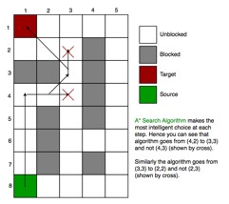

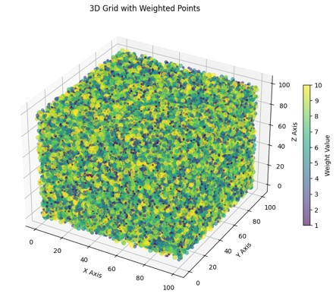

A* is used to compute the shortest path considering weights

Time expanded collision avoidance ensure that path don't overlap at the same time

The 3d plot visualise path for each with an unique colour

# Drone in auto mode using way points

1. **Defining Waypoints**
   * A set of 15 waypoints is defined, with each waypoint consisting of latitude, longitude, and altitude coordinates.
2. **Planning the Mission in Auto Mode**
   * The mission is planned using DroneKit or PYMAVLink in auto mode.
   * Upon reaching the 10th waypoint, a new waypoint is added, located 100 meters perpendicular to the drone’s current direction.
   * The drone will continue its journey and land at the final waypoint.

